**Almond Butter Scoops**

Red, Blue, Purple Dishers & Spatula

**Peanut Butter Scoops**

Red, Blue

Disher & Spatula

**Banana Dishers**





**Purple/ Yellow combined**

**Ivory**

**Blue**



**Red**



**Gray**

**Green**



**Water**

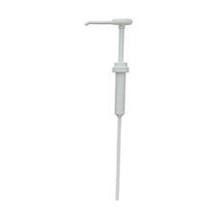

**Oat**

**Milk**

Pure

**Coconut**

**Water**

**Pure**

**Recharge**

Pure

**Coffee**

**Ap BLUEBERRY**

**Pr PASSION**

**FRUIT**

**Apple**

**KIWI**

**Ap**

**Papaya**

**Ap PINEAPPLE**

**Strawberry**

**(No Sugar Added)**

Purple (2oz) Ladle

Gray (3oz) Ladle

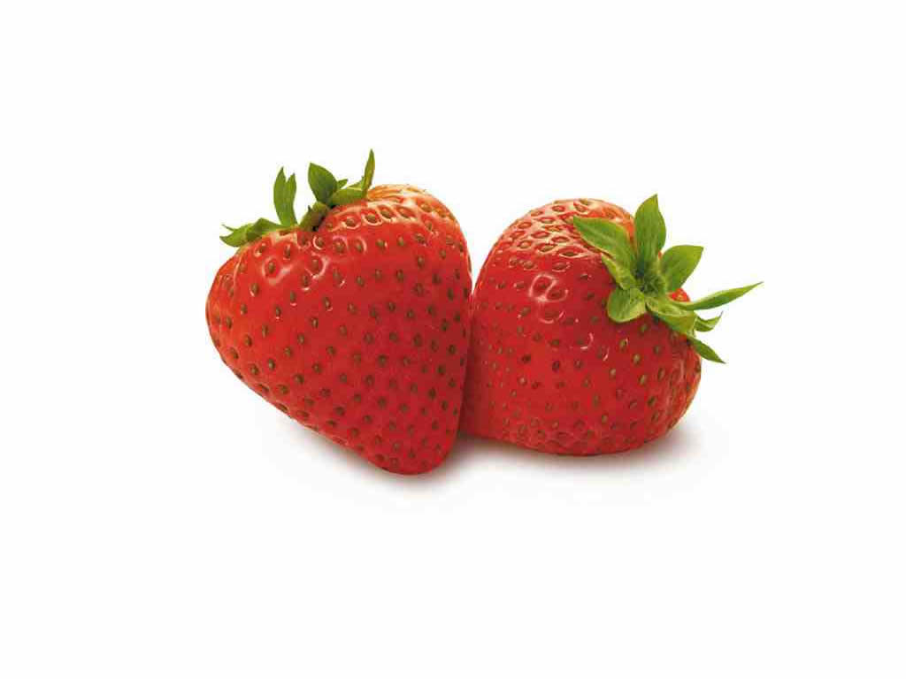

**STRAWBERRIES W SUGAR**

Blue Ladle

Tan Ladle



**Pine-apple**

Blue & Ivory Disher

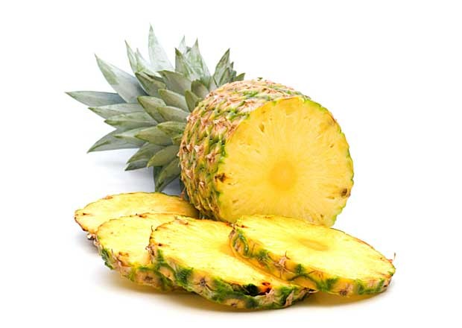

**Raspberry**

Black & Blue

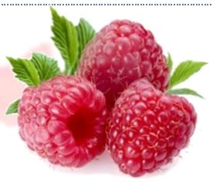

**Wild Blueberries**

Red & Green Ladle

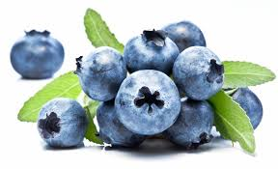

**Electrolyte Blend**

**IQF Mango**

Green & Gray Disher

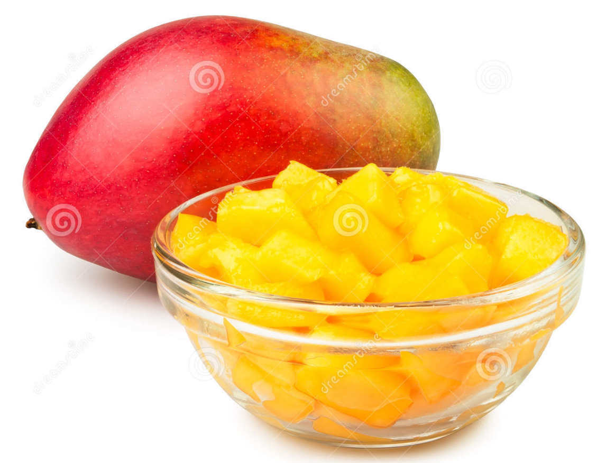

**Other Dishers**



**Yellow**



**Green**



**Purple**



**Red**

**&**

**70 Disher**



**Pear Juice**

**Coffee**

Pure

**Almond Milk**

Pure

**Banana**

See Recipe for Disher

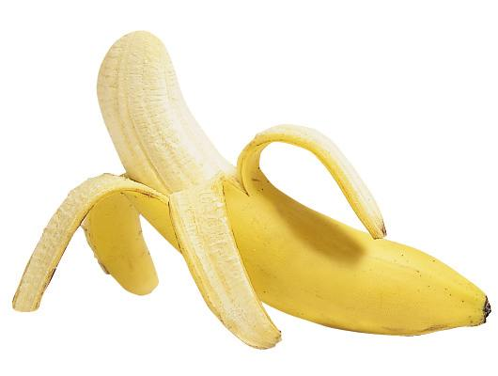

**Wht Grp LEMON**

**Almond Butter Scoops**

Red, Blue, Purple Dishers & Spatula

Any remaining Watermelon will need to go under prep unit

**Peanut Butter Scoops**

Red, Blue

Disher & Spatula



**Banana Dishers**





**Purple/ Yellow combined**

**Ivory**

**Blue**



**Red**



**Gray**

**Green**

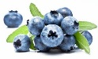

**Mango**

Green and Grey Disher



**Pine-apple**

Blue & Ivory Disher



**Raspberry**

Black & Blue



**Blueberries**

**- Wild**

Red & Green Ladle



**Straw-berries**

**(No Sugar Added)**

Purple (2oz) Ladle

Gray (3oz) Ladle



**STRAWBERRIES W SUGAR**

Blue Ladle

Tan Ladle



**Banana**

See Recipe for Disher



**Other Dishers**



**Yellow**



**Green**



**Purple**



**Red**

**&**

**70 Disher**



**Water**



**Electrolyte Blend**

**Pear Juice**

**Wht Grp LEMON**

**Ap BLUEBERRY**

**Ap**

**PINEAPPLE**

**Pr PASSION-FRUIT**

**Apple**

**KIWI**

**Ap**

**Papaya**



**Pure**

**Recharge**

Pure

**Coconut**

**water**

**Coffee**

Pure

**Almond**

**Milk**